Dr. Bhatt is a Professor and Director of the Cognitive, Motor and Balance Rehabilitation Laboratory in the Department of Physical Therapy, and *co-Director of the Midwest Roybal Center on Health Promotion* and Translation and *the newly founded Resource Center on Minority Aging -CHECA*. She has over 25-yrs of experience in the field of balance and gait rehabilitation for geriatric and neurological populations. Her research focuses on examining interactions between the cognitive, balance, and locomotor systems and how they impact functional mobility and fall-risk. She is known nationally and internationally for her work in fall-prevention. Specifically Dr. Bhatt's research involves investigating neuromechanical basis of balance recovery from external perturbations such as slips and trips and subsequently designing intervention paradigms for reducing fall-risk in healthy and pathological populations including alternative cognitive and motor therapies such as exergaming and dance therapy. Leveraging the NIH-Stage model, her research focusses on advancing rehabilitation and health promotion interventions targeting balance control and mobility dysfunction to improve community mobility and quality of life in geriatrics and neurological populations.

Dr. Bhatt has >100 peer-reviewed publications and has been extramurally funded as the principle investigator since 2011 by agencies such as National Institutes of Health and Department of Defense. Currently she serves as the principal investigator on several NIH grants and has brought more than $10 million in grant funding to UIC.

She is also has more than 150 presentations at national and international conferences and is recognized as a speaker globally. Dr. Bhatt's currently coordinates the Case Management course within the DPT program and teaches in areas related to biomechanics, motor control and rehabilitation sciences within the MS program. She is also the program coordinator for the MS in Rehabilitation Sciences program housed within the PT department. Dr. Bhatt provides her service to the profession by volunteering for the section on Geriatrics, and Research and the Academy of Neurologic Physical Therapy within the APTA. She also serves as a grant reviewer and peer-reviewer for journals globally.

[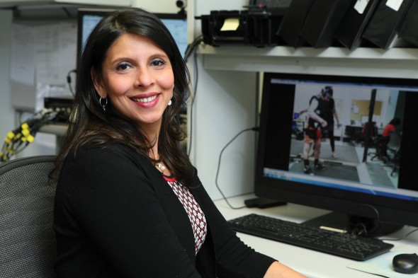](https://news.uic.edu/files/2017/01/Bhatt.Tanvi13.jpg)